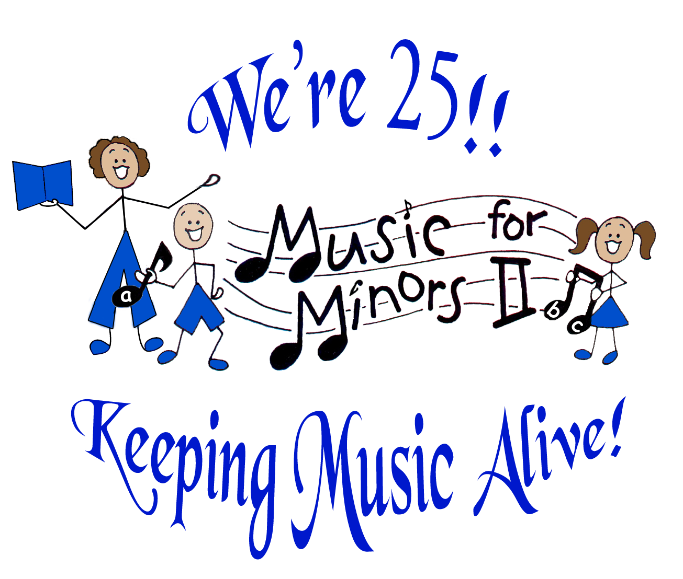
MUSIC FOR MINORS II

Serving the community since 1988

Board of Directors

President
Virginia Williamson

Board Members
Jessica Chang Kapushinski
Susan Lesh
Rachel Bello
Veera Kazak
Christina Melnarik
Lelia Ng
Ed Mateo

Executive Director
Carol Zilli

Admin. Asst. / Liaison Coordinator
Sharon Filippi

Program Coordinator
Susan Lesh

Docent Manager/ Training Coordinator
Sandy Shimkus

Docent Training Coordinator - CV
Rose Godfrey

▪▪▪

Advisory Council

Ted Bresler,
Alameda County Arts Commission

Steve Cho,
Fremont Symphony

Charlotte Diamond,
Recording Artist

Jerry Green,
Retired Director,
CV Adult School

Peggy Herndon,
CFO - Floor Seal Technology

Leo Hinkel,
Retired Principal

Brian Hughes,
Fremont Bank

Terry Liebowitz,
Castro Valley Arts Foundation

Lily Mei,
FUSD Board

Ray Rodriguez,
NUSD Board

Margaret Thornberry,
Fremont Cultural Arts Council

37141 Second Street, Fremont, CA 94536
510-733-1189 phone/510-713-9879 fax
www.musicforminors2.org
“Nurturing a lifelong love & literacy of music in children’s classrooms and lives”

Invitation to Participate / Request for Auction Donations

Music for Minors II is a non-profit organization that trains docents to provide music in children’s classrooms throughout the East Bay. We are “Celebrating 25 Years of Music, Magic and Memories,” keeping music alive in children’s classrooms and lives! Our 25th Anniversary Gala Benefit Event on Friday, March 15, 2013 at 6:30 pm at the Fremont Marriott Hotel will celebrate this milestone and raise funds to expand our program to reach many more children in need.

We are requesting donations for our live and silent auctions to be held the evening of the event. We will accept large and small donations, such as gift certificates, bottles of wine, rental property for a weekend, facility usage, food items, merchandise, art, musical instruments, anything appropriate to your company or business, professional services, or something else you prefer. You may donate themed baskets, or we will arrange your donated items in baskets for the silent auction.

Music for Minors II is a nonprofit 501 (c)(3) organization, EIN #94-3102307, and contributions are 100% tax deductible. You will receive a receipt for any donations.

By donating products or services to the auction, you are demonstrating your support of Music for Minors II in a very visible way. Your donation will provide these benefits to your business:
- Listing in the printed program
- Exposure to an upscale audience
- Your items beautifully displayed the evening of the event
- Online exposure as part of our online auction

Please complete this Auction Donor Form below:

_______________________________ ____________________________
Donor Organization Donor Contact

_______________________________________________________________________
Address / Phone / Email address

_______________________ __________________ __________________
Item or Service Donated Value Pick-up Date/Time

Please send to: Questions? Contact:
Music for Minors II Virginia Williamson
37141 Second St. 510-582-9761
Fremont, CA 94536 ginnydon@pacbell.net
FAX: 510-713-9879

THANK YOU so much for your support of Music for Minors II!

